FINAL CODE

TEAM ID PNT2022TMID15007

PROJECT TITLE Hazardous area monitoring for industrial plant powered by IoTDATE 16-11-2022

**ALGORITHM:**

1. Start

2. Import 3 modules

3. Create the IBM IoT platform device

4. Give device id

5. Connect the device

6. Introducing my command call back function

7. Get a random temperature and humidity values

8. Loop infinitely

9. Print the random temperature and humidity values on console

10. Publish the values to IBM Watson IoT platform

11. Stop

**SOURCE CODE:**

#connecting the python to IBM watson IoT platformimport wiotp.sdk.device

import timeimport randommyconfig = {

"identity":{"orgId":"zvvqaf","typeId":"IoT_devices","deviceId":"12345"

},"auth":{

"token":"qagOTm?(qV+deBQ*j*"

}

}

def myCommandCallback(cmd):

print("Message received from IBM IoT platform: %s" % cmd.data['command'])

m=cmd.data['command']

client = wiotp.sdk.device.DeviceClient(config=myconfig, logHandlers=None)

client.connect()

while True:temp=random.randint(-20,125)hum=random.randint(0,100)myData={'temperature':temp, 'humidity':hum}

client.publishEvent(eventId="status", msgFormat="json",data=myData,qos=0,onPublish=None)

print("Published data Successfully: %s",myData)client.commandCallback =myCommandCallbacktime.sleep(2)

client.disconnect()

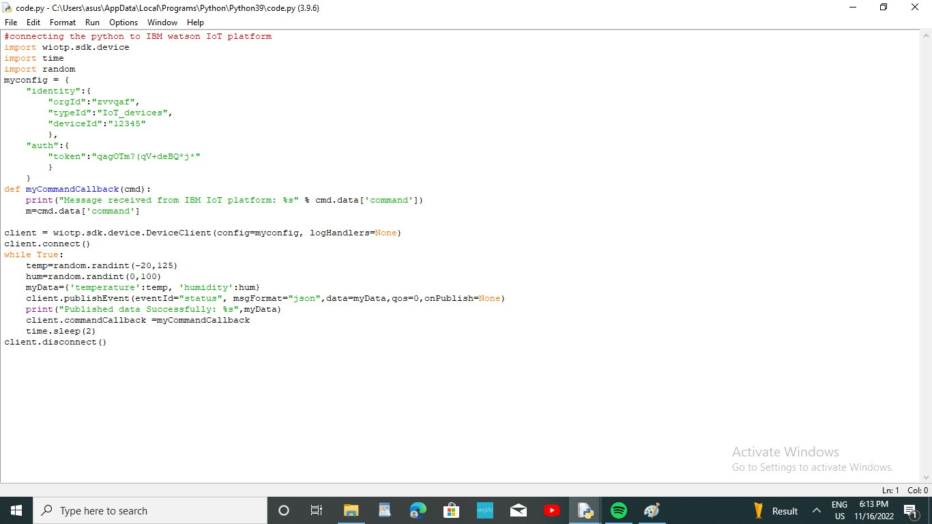

**Fig. Screenshot of python code**